Unit Test Document

By Nobody (Team 3: Caleb Corlett, Ryan Nodarse, Patrick Storer, Ethan Wyman)

**Unit Tests**

initialize_grid(self, p_width, p_height)

| **Valid** | **Invalid** |
| --- | --- |
| p_height > 0 | p_height<0 |
| p_width > 0 | p_height<0 |

cam_move_hori(self, p_delta_px)

| **Valid** | **Invalid** |
| --- | --- |
| p_delta_x != 0 | p_delta_x == 0 |

cam_move_vert(self, p_delta_px)

| **Valid** | **Invalid** |
| --- | --- |
| p_delta_x != 0 | p_delta_x == 0 |

get_grid_loc(self, p_pos)

| **Valid** | **Invalid** |
| --- | --- |
| p_pos is a tuple | p_pos is not a tuple |
| length of p_pos == 2 | length of p_pos !=2 |
| p_pos(x) >= 0 | p_pos(x) < 0 |
| p_pos(y) >= 0 | p_pos(y) < 0 |
| p_pos contains only integers | p_pos contains non-integers |

establish_grid_neighbors(self, p_width, p_height)

| **Valid** | **Invalid** |
| --- | --- |
| p_height > 0 | p_height<0 |
| p_width > 0 | p_height<0 |
| Grid dimensions divisible by grid size | Grid dimensions not divisible by grid size |
| Grid size > 0 | Grid size < 0 |

def zoom(self, grid_size_modifier)

| **Valid** | **Invalid** |
| --- | --- |
| grid_size_modifier > 0 | grid_size_modifier <= 0 |

def rotate(self, p_direction, p_gridspace=None, p_floortile=None, num_rotates=1)

| **Valid** | **Invalid** |
| --- | --- |
| p_direction must be left or right | p_direction not left or right |
| num_rotates > 0 | num_rotates < 0 |

def draw_floortile(self, p_gridspace)

| **Valid** | **Invalid** |
| --- | --- |
| Valid Database connection | Invalid database connection |
| Properly initialized p_gridspace | Uninitialized or invalid p_gridspace |

**Use Case Tests**

**Use Case Test for "Game Settings Configuration"**

Test Title: Testing Game Settings Configuration

Test Description: This test verifies that players can configure game settings according to their preferences before starting a session.

Test Steps:

1. Open the game and navigate to the settings menu.
2. Verify that options such as difficulty level, game mode, and communication settings are available.
3. Select a difficulty level and verify that it is reflected in the settings.
4. Choose a game mode (synchronous or asynchronous) and verify that the selection is saved.
5. Adjust communication preferences and ensure they are applied correctly.
6. Confirm the settings and ensure they are saved for the upcoming session.

Expected Result: All selected settings should be accurately configured and saved for the session.

**Use Case Test for "Haunt Trigger and Scenario Resolution"**

Test Title: Testing Haunt Trigger and Scenario Resolution

Test Description: This test verifies that the game system triggers the haunt phase and resolves the selected haunt scenario correctly.

Test Steps:

1. Begin a game session and progress through the exploration phase.
2. Ensure that haunt trigger conditions are met according to the game settings.
3. Verify that the haunt phase is initiated automatically.
4. Check that the haunt scenario selected corresponds to the established game settings.
5. Review the roles and objectives assigned to players for the haunt scenario.
6. Play through the haunt scenario, ensuring that actions are resolved accurately.

Expected Result: The haunt phase should be triggered correctly, and the selected haunt scenario should be resolved accurately according to the established game settings.

**Use Case Test for "Post-Haunt Resolution and Conclusion"**

Test Title: Testing Post-Haunt Resolution and Conclusion

Test Description: This test verifies that players can reflect on the haunt experience, review game settings, and make decisions for future sessions.

Test Steps:

1. Complete the haunt phase and conclude the game session.
2. Enter the post-haunt resolution phase and review the events of the haunt.
3. Navigate to the game settings menu and ensure that current settings are displayed.
4. Consider any desired adjustments to game settings and apply changes.
5. Discuss future session decisions with other players and agree on a course of action.
6. Confirm the decisions and ensure they are saved for future sessions.

Expected Result: Players should be able to reflect on the haunt experience, adjust game settings as desired, and make decisions for future sessions with ease. All decisions and settings changes should be accurately saved for future use.

**Use Case Test for “Ending Turn”**

Test Title: End Turn

Test Description: This test verifies that the user is presented with a message that they want to end their turn, and the turn successfully progresses to the next player.

Test Steps:

1. User selects “end turn”
2. Ensure that a confirmation message is displayed
3. Ensure user confirms that they want to end their turn
4. Confirm that the multiplayer system verifies the end of the user’s turn
5. Ensure that the system progresses to the next player’s turn

**Use Case Test for “Use Items”**

Test Title: Use Item

1. User selects an item in their inventory
2. System displays description of item
3. User confirms their usage of item
4. Ensure item’s affects are applied to game
5. Display outcome of item’s usage to user

**Acceptance Testing**

Screenshots of testing: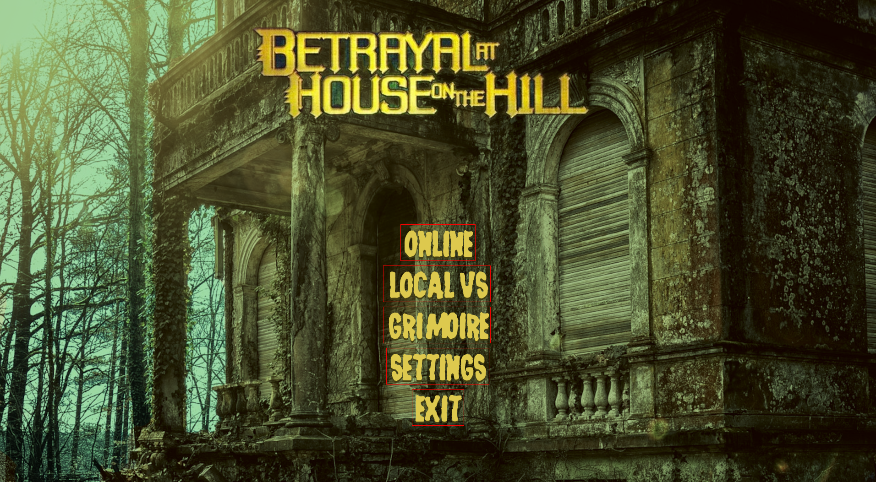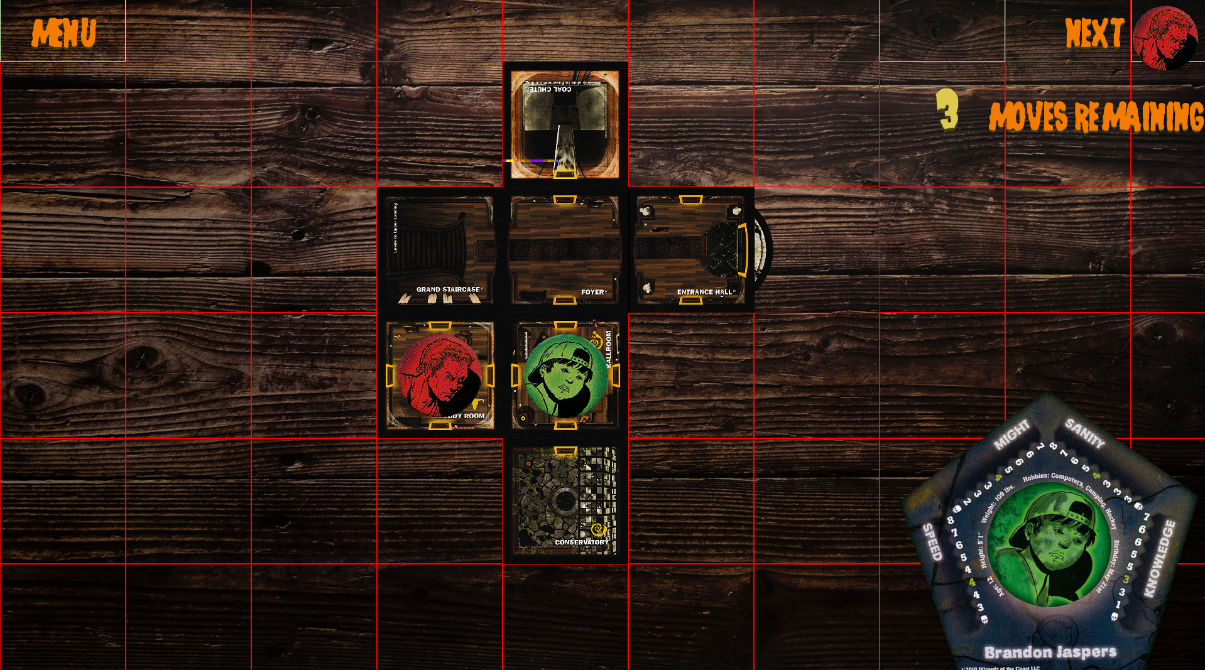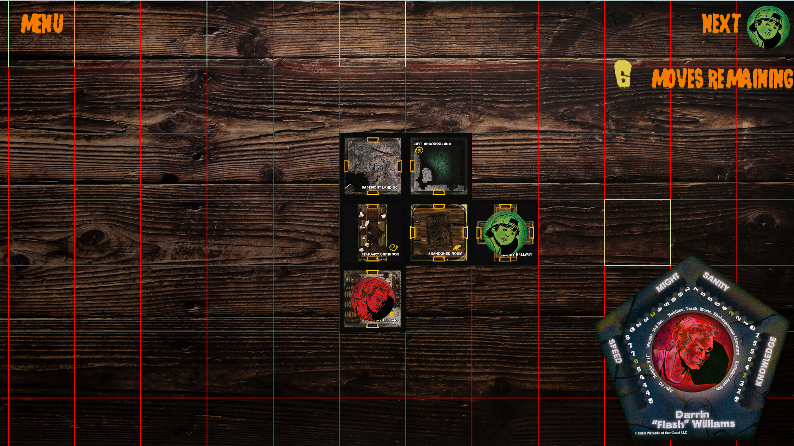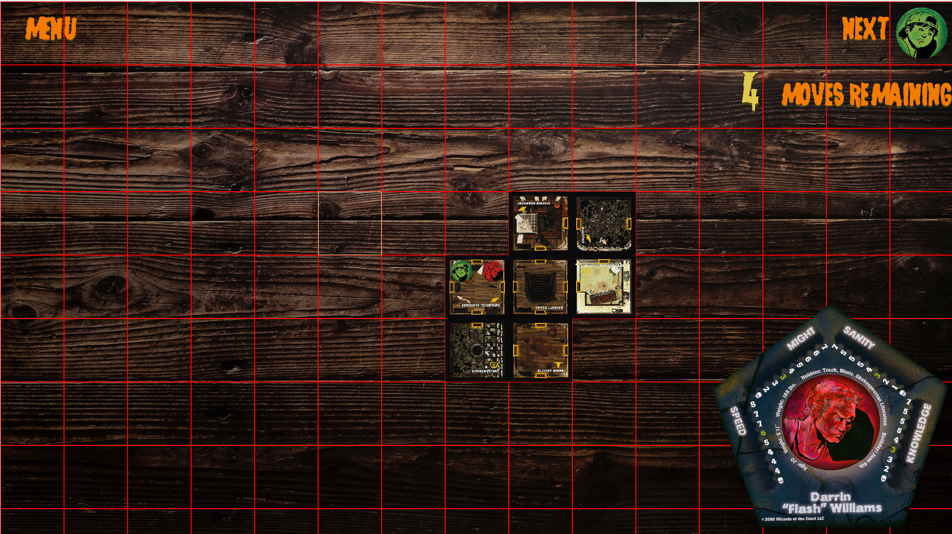

**Feedback from users** (same people from Focus Group & Usability Study):

*Will F*: Although there are some bugs at this stage, the art style is pleasant, and it definitely represents the mock-up and the original game. I’d recommend changing the number that represents remaining moves as it’s unclear against the background.

*Bri C*: The tiles are hard to read, and it takes a bit too much effort to understand what’s going on on the board. The icons are too big and I feel like I need more information to know whats going on.

*Eric H*: Desperately needs more features and user functionality. Although it looks like it has some impressive core features, this isn’t in a state that I would want to use frequently. I’d recommend making the player icons smaller so I can see more of the room.

*Mariah D*: Reduce the number of bugs. The main menu looks nice and I like the options highlighting and getting bigger when I hover over them. I’d prefer if the gridlines were more opaque, and the number in the top right (movement remaining number) looks silly. Use the same or similar font for the number, and maybe a less harsh yellow. The bottom right character board is too big and should only look this big if I hover over it.